**UNIVERSITY OF THE WEST OF SCOTLAND**

**COMP11032 OBJECT-ORIENTED ANALYSIS AND DESIGN**

**SUBMITTED DATE: 20/07/2023**

**SUBMITTED TO: Dr. SHAHID AWAN**

**STUDENT NAME : VISAKH VATTAVATH VINOD**

**STUDENT ID : B01645695**

**Topic: Property Rental System in the UK**

**Declaration**

I declare that this is an original study based on my own work.

VISAKH VATTAVATH VINOD

**TABLE OF CONTENT**

USE CASE DIAGRAM…………………………………………………………………… 4

USE CASE DESCRIPTION………………………………………………………………. 5

* Registration Scenario……………………………………………………………… 5
* Log in Scenario……………………………………………………………………. 5
* Property Search and Listing Scenario……………………………………………... 5
* Property Selection Scenario………………………………………………………...5
* Property Initial Agreement Scenario………………………………………………. 6
* Property Final Agreement Scenario……………………………………………….. 6
* Property Review and Response…………………………………………………… 6

CLASS DIAGRAM……………………………………………………………………….. 7

SEQUENCE DIAGRAM………………………………………………………………….. 8

**USE CASE DIAGRAM**

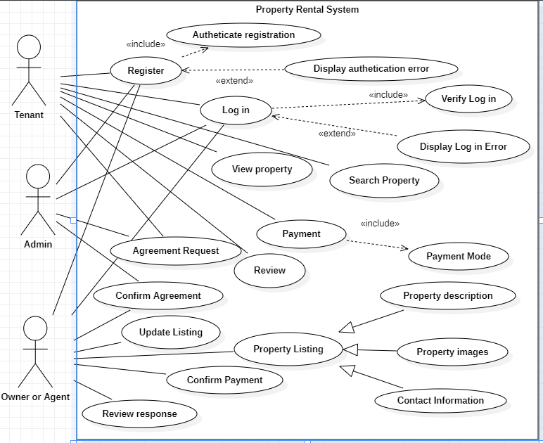

**USE CASE DESCRIPTION**

* **Registration Scenario**

If (registration valid)

then

Display “Registration successful”

Else (registration invalid)

then

Display “Authentication error”

* **Log in Scenario**

If (verified password)

then

Log in

Else (not verified)

then

Display “error”

* **Property Search and Listing Scenario**

Case 1 (looking for property)

then

Display available property

if (property matching found)

then

Display property details and contact information

Else

then

Display “no matching properties”

Case 2 (listing property)

then

User can enter details of listing, images, rent amount

* **Property Initial Agreement Scenario**

If (tenant select a property for rent)

Then

Tenant can intiate agreement request

Owner can confirm or reject agreement request

* **Property Final Agreement Scenario**

If (agreement accepted by both tenant and owner/agent)

Then

Confirms rental duration and payment

Marked property as “Sold”

Else

Then

Reject agreement

* **Property Review and Response**

If (tenant rented property)

Then

Tenant have the option to write review

Owner/ agent have the option to respond to tenant review

**CLASS DIAGRAM**

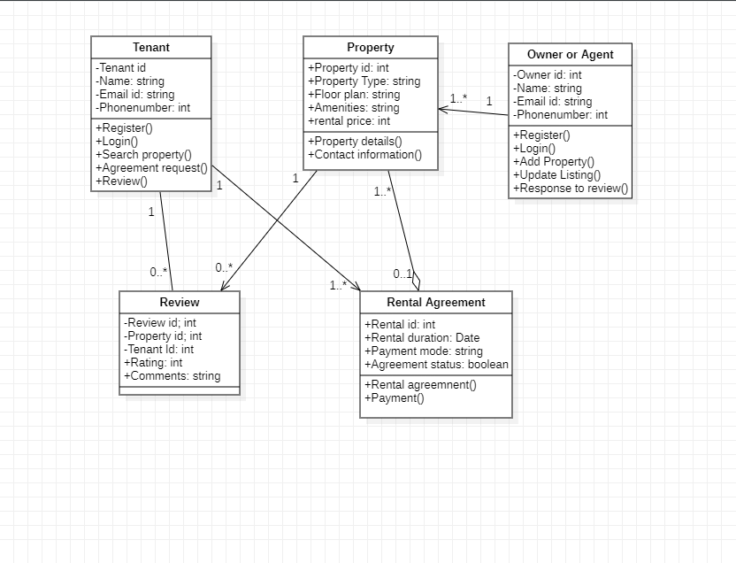

**SEQUENCE DIAGRAM**

